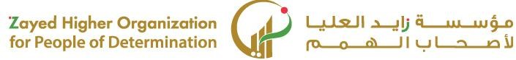

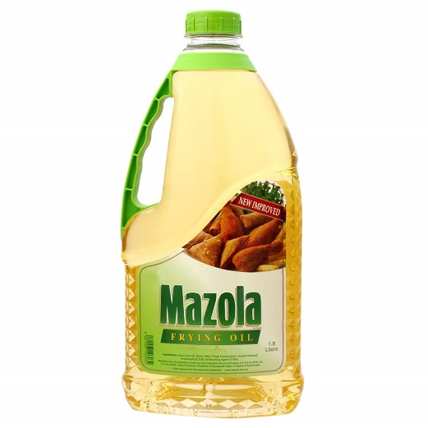 **الدرس رقم 16: التعرف على طريقة الطبخ ((السلق))**

